Class E’ retelling a story.
Once upon a time, a long time ago there were three kingdoms, the one of the dogs’ in far away land of Kalevala, the one of the wolves’ and the one of the cats’.
Each clan had their own wizards and the wizard of the dogs’ was the mean Vainamoinen. He loved to play bad tricks on the other dogs.
But young Yukahaainen wanted to help poor dogs so he met a friend of his who was a smith to ask for help. The smith made two armors in order to help fight evil Vainamoinen.
After five days of travelling Yukahaainen and his friend reached Kalevala and they saw the wizard making spells to a little child..Then the smith said that it would be impossible to beat him. They soon asked for help from the witch of the the wolves, Luhi. They explained the situation and she agreed to help. One night while they were eating together , Vainamoinen saw them through a magic globe and he sent the huge Cyclops to eat them .Luhi had a bad feeling and sometime later after a hard fight they managed to beat the Cyclops.

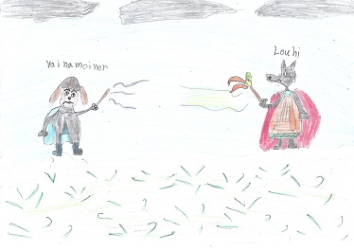
Some time later , Yukahaainen and the smith made an object that produced salt, flour and money. It was called Sambo. They handed it to Vainamoinen. But he didn’t keep his promise to have peace and using his spells he hypnotized everybody to fight with the wolves in order he to become their king. The dogs arrived at the land of the wolves and at that time Luhi with her spells beated some dogs but Yukahaainen retreated and went to the land of the cats’. He met Ahti and asked for help and dogs and cats altogether went to fight with the dogs. When they came back Luhi managed to solve the spells.

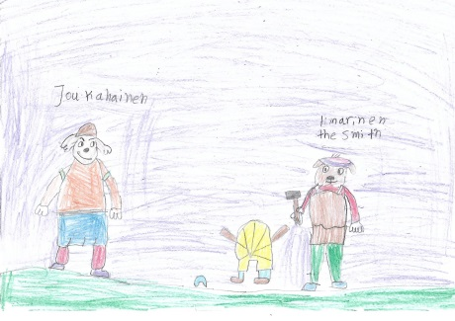

Vainamoinen was transformed into an eagle, rushed fiercely and went to take the magic stick. Using spells Luhi made a prison and she pushed the wizard. He took his magic wand so the wizard could do nothing without it. So Kalevala without this evil person had a peaceful life.

